CIS11 Unit 2 Assignment: Digital Logic Structures
Refer to class lecture presentation notes and Chapter 3 in textbook to complete the following questions.
- Describe the function of a transistor in a microprocessor.
A transistor is the basis for all logical operations in a microprocessor.
- Identify the states of switch-based circuits.
True or false.
- Describe the differences between n-type and p-type MOS transistors.
N-type and P-type MOS transistors operate simmilarly, except the direction from which current is drawn is opposite of the other.
- What are the voltage ranges for “0” and “1” in digital logic structures?
It is dependant on the transistor, but you can find voltages from 5, 3.3, 1.3, 0.6. Modern transistors used in modern CPUs can use as little as 0.3v.
- Identify the below logic gates:

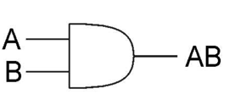 And

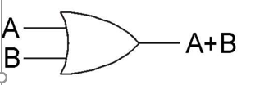 Or

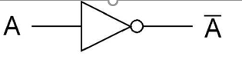 Not

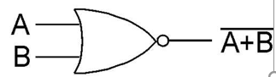 XOR

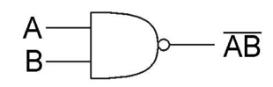 NAND

- Explain the DeMorgan’s Law in relation to AND, OR and NOT logic.

All logic gates other than AND, and NOT can be represented with AND, and NOT gates, or vice versa with OR, and NOT.

- Determine the output for the following problems:

1 0 1 0 1 1 1 0
NAND 0 1 0 1 1 0 1 1
1 1 1 1 0 1 0 1

1 1 0 1 1 0 0 0
NAND 1 1 1 0 0 0 1 1
0 0 1 1 1 1 1 1

1 0 0 0 1 1 1 1
NOR 1 1 0 1 0 0 1 0
0 0 1 0 0 0 0 0

1 1 1 1 1 1 0 1
NOR 1 0 0 0 0 0 1 0
0 0 0 0 0 0 0 0
- What is the purpose of a decoder in logic functions?
A decoder converts binary representations of values to individual on or off states in specific wires.
- Describe the purpose of a multiplexer in logic functions.
A multiplexer, somewhat like a decoder, allows the routing of data from one place to another through the use of slection of which pin should pass It’s state through binary representation.

- Explain the purpose of a binary adder, full adder, in digital logic structures.
A binary adder is the simplest form of adder which is capable of only adding two single bits. These can be combined to make full adder which can carry bits and incorporate carry bits to add bull binary numbers.
- Describe the differences between combinational and sequential circuits.
Combinational circuits can be thought of as boolean algebraic expressions, in a sense that they perform all of their calculations in “one pass”, or that they have no time components. They are stateless machines. Sequential circuits do have a “time-component” and store state. They process information in a series of steps.
- Define the purposes of R-S Latch in storage element.
A R-S Latch in some essence acts as the “building block” of storage, capable of storing a singular bit, and is used in D-Latches.
- Use Multibit representation to denote the highlighted bits:

D[l:r] denotes bit l to bit r, from left to right

- 1101010010100110
[15:10] = 110101
- 1101010010100110
[5:0] = 100110
- 1101010010100110
[10:4] = 1001010
- Discuss the properties of a finite state machine.
A finite state machine is a system that acts on a finite set of inputs and through a finite set of simple states performs some operation.
Login Canvas and submit Unit 2 In-Class Assignment.

